**Experiment 5:-**

Design an distance measuring device.

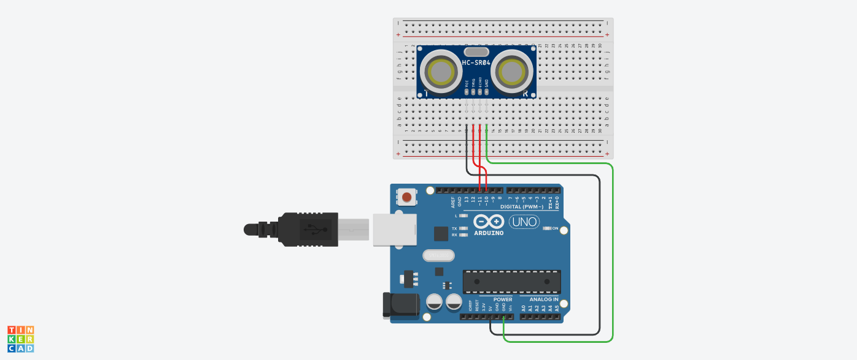**Circuit diagram:-**

**Theory:-**

Concepts used in this project:-

ULTRASONIC SENSOR

* **Ultrasonic sensors** measure distances based on transmitting and receiving ultrasonic signals.
* It consist of 4 pins namely: Vcc, trig, echo, GND.

Vcc – power supply

GND – ground

Trig - trigger pin converts electrical signal to sound wave and then transmit it and hence act as OUTPUT

Echo – echo pin receives the returned sound wave and convert it into electrical signal and hence act as INPUT

*Speed of sound:*

***v=340 m/s***

***v=0.034 cm/µs***

*time = distance / speed:*

***t = s / v = 10 / 0.034***

*distance:*

***s = t . 0.034 / 2***

**Learning:-**

* I have learned through this project how to design a distance measuring device using ultrasonic sensor.

**Observation:-**

* When we pass electrical signals through our code the LED glows.
* The serial monitor prints the distance of any obstacle in front of ultrasonic sensor.

**Problems faced:-**

The problems I faced:-

* The circuit was not working because the connections were not proper.
* The breadboard was broken.

**Precautions:-**

The precautions that should be taken while doing this experiment are:-

* The connections should not be loose.
* Every stuff should be joined at their appropriate place and it should be properly closed.
* The code should be written properly.

**Learning Outcomes:-**

* I have learned how all the hardwares should be connected to make them work in a proper condition.
* I have learned how an ultrasonic sensor works practically.